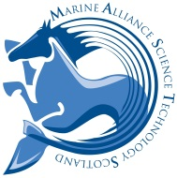
Spatial Ecology of Elasmobranchs
Trends, Advances in Methods, & Opportunities
5 September 2014 9AM-1PM
Following on from the success of last year’s 2013 workshop on research capacity in Scotland on elasmobranchs (sharks, skates & rays), the 2014 MASTS ASM hosted a second workshop. A major outcome of the 2013 workshop was the launch of MASTS Community Project SIORC (Sharks, skates and rays in the Offshore and Coastal Zone of Scotland), which has MASTS members drafting Scotland’s first prioritised research agenda on this charismatic group of animals and participating in targeted field studies. In keeping with SIORC’s progress, the theme of the 2014 workshop was “spatial ecology” so members could discuss trends in the movements, migrations and important habitats for elasmobranchs in Scottish waters, learn about methodological advances in techniques, and visit new national and global collaborative opportunities.
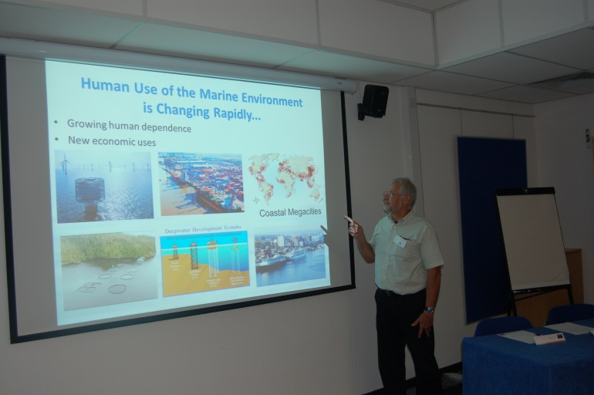
The 2014 workshop was attended by 24 people and 2 international speakers shared their expertise and vision for enhanced collaborations with Scotland. Dr. Fred Whoriskey is the Executive Director of the Ocean Tracking Network headquartered in Halifax, Canada. Dr. Whoriskey’s presentation outlined the visions of a global OTN to track the movements of migratory marine animals but also the infrastructure, expertise, and benefits available to stakeholders looking to foster data-sharing and globalise their research. Dr. Irene Kingma is the Chief Secretary of the Dutch Elasmobranch Society. Dr. Kingma discussed the Dutch experience in elasmobranch research and species recovery plans including the identification of important nursery habitats in Dutch estuaries. Both Dr. Kingma’s and Dr. Whoriskey’s talks are hosted on the MASTS website.
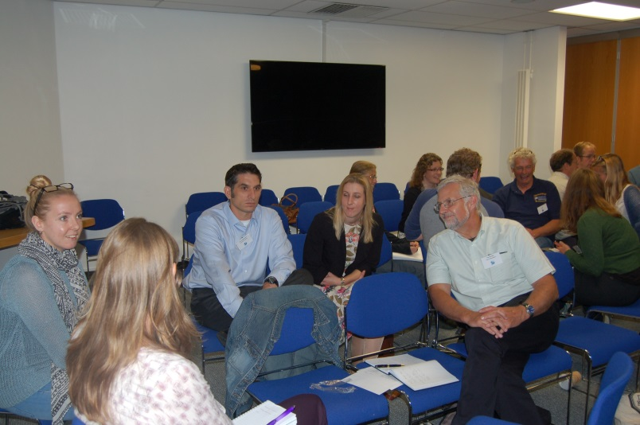
Six other talks covering a variety of spatial ecology topics were also presented, which led into break-out working groups on methods to improve the way we can capture information on important elasmobranch habitats in Scottish waters. Tasks for members in the coming months are to progress the SIORC agenda, and strengthen the links and opportunities with Dutch organisations and the OTN by preparing and submitting Scottish-led and joint research grants.

