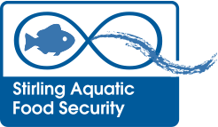
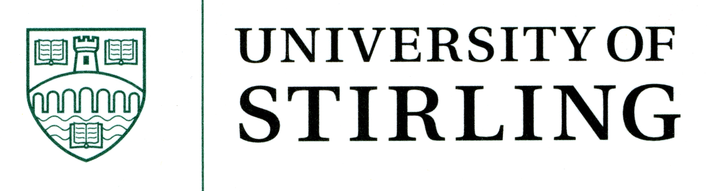

MASTS Workshop, Herriot Watt Conference Centre,
29th August 2013

CARNEGIE Room A, 10am-12noon

Food security is a complex issue both nationally and internationally. Sustainable production must take into account the need to provide sufficient quantities of safe, high quality, nutritious food, readily accessible to satisfy the global demand. The aquatic environment provides a currently under-recognised opportunity for addressing future food security challenges. One aim of this workshop is to explore these opportunities.
In response to these challenges the University of Stirling has recently decided to build on its strong research base in Aquatic Food Security and invest in new posts in this area. Another purpose of this workshop is to celebrate the launch of this new group and to identify the additional capacity it brings and potential new collaborative links.
We would like to invite you to join us at this workshop entitled

Aquatic Food Security – Scotland’s role for a global market

Presentations from guest speakers will help introduce varied “scenarios” and how these may impact Scotland’s role in seafood production. We value your participation in the open floor discussion/debate to help identify the uniqueness of seafood within food security.

AGENDA
10:00 Prof. Rachel Norman (UoS) Welcome & Introductions

10:05 Dr. Mark James (MASTS) “Aquatic Food Security & MASTS”

10:20 Dr. Neil Auchterlonie (CEFAS) “Global Seafood Supply Chain & Opportunities for Aquaculture”

10:40 Prof. Rachel Norman (UoS) “Aquatic Food Security at the University of Stirling”

The presentations will be followed by an open floor discussion with coffee/tea provided and the opportunity for networking.

