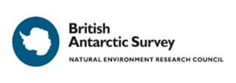

BAS Advanced Training Short Course

Safe and Effective Fieldwork in the Polar Regions

Provisional course dates: 20 August—2 September 2019*
Deadline for applications: 11 March 2019

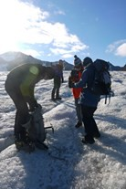
Do you know the science theory but are unsure of how to apply it on the ice? Here's a unique chance for PhD students and Early Career Researchers to gain practical skills of working safely and effectively in the polar regions. Using leading polar experts, participants will learn how to translate exciting scientific ideas into safe, achievable and effective field plans. The course consists of three days theoretical and practical work at BAS, Cambridge and five days of practical training exercises on the ice and at sea in the Arctic.
You’ll be working with some of the UK’s leading Scientists and Operations
Managers and looking at all aspects of polar science, including:

- Fieldwork planning in remote regions: how to develop a comprehensive, achievable field plan; legal, political and environmental obligations; risk assessment; shipping equipment; financial planning and budgeting. BAS Operations will give practical examples of project planning from their extensive experience in both polar regions.
- Remote sensing options and use of topographical maps: use of a GPS and GIS; aerial photographs and satellite images. Members of the BAS Mapping and Geographic Information Centre (MAGIC) will demonstrate some of the latest state of the art techniques.
- A series of tasks and practical exercises to help you develop your skills in polar leadership, practical planning and how to work efficiently in remote regions. Can you think on your feet and lead a small team? Can you change a field programme at short notice in challenging weather conditions?

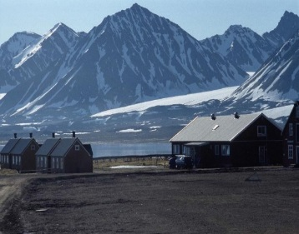
The skills learnt in Cambridge will be transferred into five full days of active fieldwork (weather permitting) at the NERC Arctic Station in Ny-Ålesund. You will work on the Midrelovenbreen Glacier and carry out a radar survey of ice structure. But these skills will apply equally to many types of earth science fieldwork. Similarly, you will work on offshore biological sampling but develop general skills in small boat survey work. You’ll be asked to help plan each day and take turns at leading the team.

The cost of the course will be approximately £1750 per person. Some possible funding sources are listed below.

Still interested? Then submit your application no later than 11 March 2019 to Ali Teague—alag@bas.ac.uk
This course is for PhD and ECRs registered with a UK academic institution. NERC-funded Doctoral Training Partnership students are particularly encouraged to apply, but other UK based UKRI PhD students and ECRs may also apply.
Numbers will be strictly limited to 12 participants.
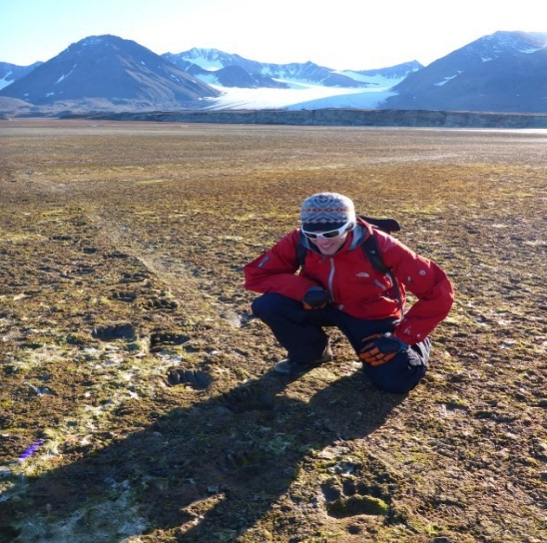

*Important. Please note:
Due to travel logistics, dates will be confirmed in due course.

Indicative timetable:-
Classroom training in Cambridge:
20 – 23 Aug.
Travel & Fieldwork training:
24 Aug – 2 Sept.

http://www.antarcticsciencebursary.org.uk/apply-for-an-asi-bursary/

http://www.transantarctic.org.uk/grant-application-procedure/

http://www.clivar.org/ecs/travel-grants

http://www.rsc.org/ScienceAndTechnology/Funding/division-travel-grants/

https://www.reading.ac.uk/internal/researchstaff/funding/rstaff-travelgrantsandfellowships.aspx

https://www.challenger-society.org.uk/Travel_awards

BRITISH ANTARCTIC SURVEY
Advanced Training Short Course

Safe & Effective Fieldwork in the Polar Regions
APPLICATION FORM

Course Dates 20 August – 2 September 2019*
Deadline for applications: 11 March 2019
In Confidence

Surname: ................................................................................

First Name:............................................................................

Permanent Address:..................................................................................................................

Email Address: .......................................

Tel No (Work & Mobile)...................................................

University or Research Centre Affiliation:………………………………………….

Department Name:…………………………………………………………………………

Thesis or Project Title:……………………………………………………………………

Principal Supervisor/Departmental Manager Name & Email Address: ………………………………………

Are you currently funded by:-

NERC DTP [ ] (please specify) ……………………………………………………

Other Research Council DTP/CDT [ ] (please specify)……………………..

EU [ ] (please specify)……………………………………………………………………

Other [ ] (please specify)........................................................................

Please give details of:-

Any outdoor interests or skills:

Other interests or hobbies:

Any medical conditions including allergies:

Special Dietary requirements: (please specify)

Please remember to submit:
- Your full CV
- A letter of motivation (maximum of two sides of A4, 11pt font) which includes a brief description of your PhD/postdoc topic, and how you think you will benefit from this course.

Please note, if selected to participate you will be required to provide a contribution (approximately £1750.00) towards the cost of the course, payable before 30th June 2019. Non payment may result in your place being offered to a reserve candidate.

Course costs cover:-
- meals and accommodation 20, 21, 22 August in Cambridge*
- return travel from Cambridge to Heathrow airport
- return travel, accommodation, subsistence from Heathrow airport to Ny-Ålesund
All other expenses must be met by the participant
*All course dates to be confirmed

Name As It Appears In Your Passport……………………………………………………………….

Passport Number…………………………………………..

Expiry Date (must be valid until at least 31 January 2020)…………………………..

I confirm that I am fully insured by my institute for travel to the Arctic and Arctic fieldwork [ ]

I confirm my institute will provide Arctic travel/fieldwork insurance [ ]

I confirm I am free to attend on the specified course dates* [ ]

I confirm I am a UK-registered PhD student or ECR working in a sector aligned to NERC’s science remit [ ]

Signature………………………………………………………………………………..

Please return your completed form, CV and letter of motivation to Ali Teague alag@bas.ac.uk to be received no later than 11 March 2019

