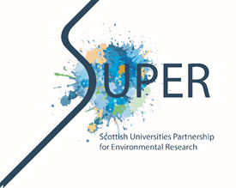 | “The Scottish Universities Partnership for Environmental Research”  Doctoral Training Partnership Call for Outline Proposals

Application Form for Outline Proposals from PhD Supervisors

- INFORMATION ABOUT THE PROPOSED PROJECT
- Proposed project title (max 25 words)
- Which type of SUPER studentship are you applying for? Standard, CASE or Collaborative? Please provide brief details.
- Which Theme(s) under the SUPER ”Catchment to Coast” umbrella does this project address (max 300 words)
- Project description, background and rationale of the research project (max 800 words)
- What research methods are likely to be used? (max 300 words)
- What contribution to impact do you believe the research will make, what deliverables or outcomes are likely, and why is this research important? (max 300 words)
- Does this studentship have any dependencies? (i.e. on any cruises, specialist facilities, software, high cost items etc) (max 100 words)
- INFORMATION ABOUT THE SUPERVISORY TEAM
- INFORMATION ABOUT THE PRIMARY SUPERVISOR
Primary Supervisor’s Name
Primary Supervisor’s Email address
Primary Supervisor’s Institution
Primary Supervisor’s PhD supervision track record
- INFORMATION ABOUT THE SECOND SUPERVISOR
Second Supervisor’s Name
Second Supervisor’s Email address
Second Supervisor’s Institution/Organisation
Second Supervisor’s PhD supervision track record
- INFORMATION ABOUT THE THIRD SUPERVISOR (if required)
Third Supervisor’s Name
Third Supervisor’s Email address
Third Supervisor’s Institution/Organisation
Third Supervisor’s PhD supervision track record

