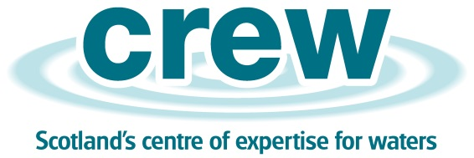
For CREW Use Only
Proposal Code
Date received

Expression of Interest – Applying for a Collaborative Project for the Centre of Expertise for Waters (CREW)
This application together with any supplementary material must be returned to CREW by the closing date. An electronic version of the completed form must be emailed to: masts@st-andrews.ac.uk
- Applicants must ensure that they are able to accept the terms and conditions of the standard CREW contract before submitting proposals.
- Applicants should complete each part of the form as fully as possible.

PROPOSER’S DETAILS
1. | Proposer’s full name and title |  | Tel: No. (incl.  STD code)

Position |  | Email

2. | Name and address of organisation |  | Postcode

SECTION ONE – SUMMARY
3. | Project code and title.

SECTION TWO – SCIENCE
4. | Approach.  With reference to the defined project objectives, please outline (in 1 page) your areas of expertise and methodological approach.

SECTION THREE – RESOURCES & MANAGEMENT
5. Project Participants.
Please identify the names of any institutions and associated named staff members who would be directly involved in the delivery of the project.

6. Project Risks.
Please identify any risks to the delivery of the project and how these will be managed.

7. Relevant publications and projects.
Supporting your response to (4), please summarise evidence (e.g. recent relevant publications or projects which you and your project partners have undertaken) which would help to demonstrate your capacity to deliver the proposed project.

The completed form using the CREW Project Code in the subject line must be emailed to: masts@st-andrews.ac.uk

