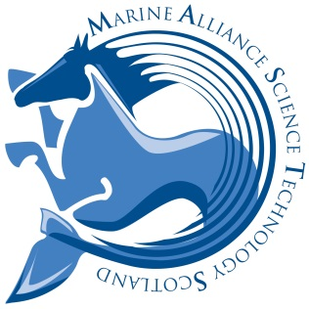 | MASTS, Scottish Oceans Institute  East Sands, St Andrews, Fife KY16 8LB  Email: masts@st-andrews.ac.uk

Application for Associate Membership of MASTS

One electronic copy of this application together with any supplementary material must be returned to MASTS at: masts@st-andrews.ac.uk

Applicants should complete each part of the form as fully as possible.

APPLYING ORGANISATION’S DETAILS

Which category of associate membership are you applying for? | Choose an item.
Name of Organisation

Name and contact details of the principal contact within the organisation dealing with associate membership

APPLICATION FOR ASSOCIATE MEMBERSHIP
Information regarding the applicant organisation. Please provide basic details regarding the applying organisation (e.g. size, area of expertise, involvement in marine science etc). This section of text should not exceed one side of A4 at a minimum of font size 12. This table will expand to accommodate the information you wish to enter.

Rationale and justification for request for Associate Membership of MASTS. To include why the organisation wishes to become an associate member of MASTS, what the organisation hopes to gain from associate membership and what they might contribute in terms of building the MASTS marine science community. This section of text should not exceed one side of A4 at a minimum of font size 12. This table will expand to accommodate the information you wish to enter.

CHECKLIST

Before submitting your application, please ensure you:
- Have read and comply with the ethics statement regarding associate membership of MASTS
- Are able to sign up to the MASTS Associate Membership Standard Agreement if your application is successful. Please note this agreement will only be varied under very exceptional circumstances.

