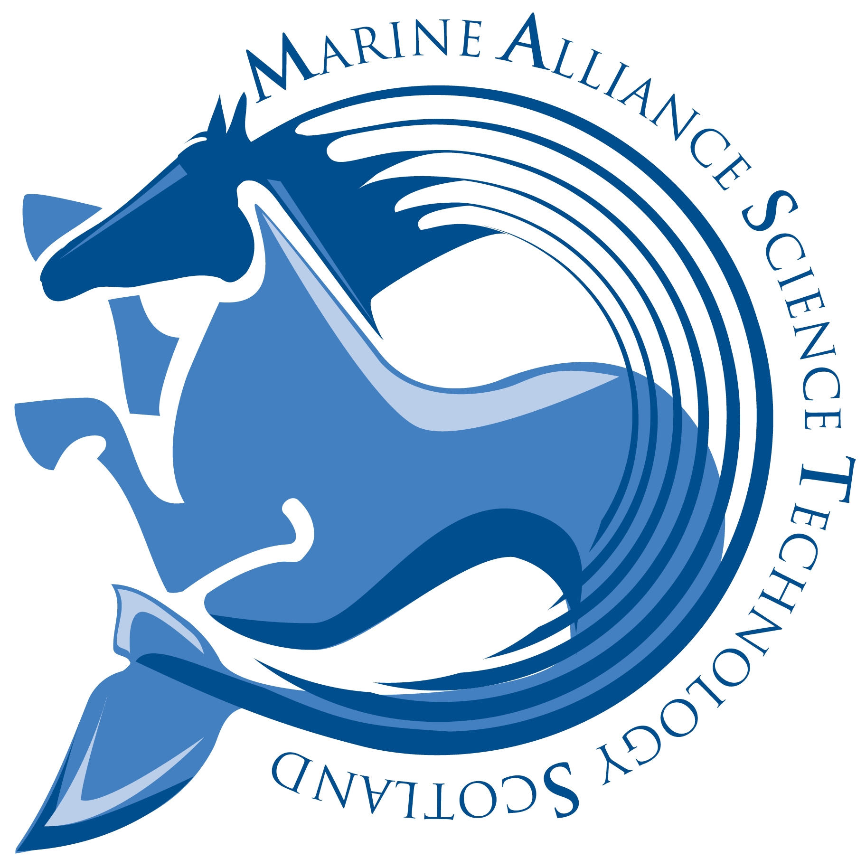 | MASTS, Scottish Oceans Institute  East Sands, St Andrews, Fife KY16 8LB  Email: masts@st-andrews.ac.uk

Application for a Student Bursary from MASTS SUSTAINABLE AQUACULTURE FORUM

One electronic copy of this application together with any supplementary material must be returned to MASTS by email by the closing date. The completed form should be returned to: masts@st-andrews.ac.uk
- Applicants should complete each part of the form as fully as possible.
- To move from one fill-in location (field) to another, press the UP or DOWN arrow or click the location, unless directed otherwise.

MASTS members can apply for a maximum of £1000 towards the cost of a student research based project (i.e. such as a summer student project/internship or part of a PhD project).

Proposals must involve a minimum of two MASTS institutions in order to foster enhanced collaboration amongst the MASTS network.

Eligible costs could include, travel, subsistence, accommodation, equipment/consumables, or training costs. Staff costs are not eligible.

PROPOSERS DETAILS

1. | Proposer’s full name and title |  | Tel: No. (incl.  STD code)

 | Position held |  | Fax No.

E-mail address

2. | Name and address of (lead) organisation |  | Postcode

WHAT YOU INTEND TO DO AND WHY?

3. | (a) Small Grants Scheme title (maximum 120 characters)

- Rationale and justification for request for Small Grant Scheme funding. To include the main objective, relevance to MASTS and any intended outputs or deliverables. This section of text should not exceed two sides of A4 at a minimum of font size 12.
This table will expand to accommodate the information you wish to enter. To move to the next field, press the DOWN arrow.

(c) Total cost to MASTS  (max £1000 inclusive of VAT) |  | (d) Date submitted to MASTS

 | (e) Duration |  |  | (f) Proposed start date)

COSTS

4. | Summary of total estimated costs (inclusive of VAT) This should include the costs of work/activity which will be funded by (a) MASTS, (b) Bodies other than MASTS, (c) ‘in kind’ contributions as a value, as appropriate. Please provide adequate information to allow reviewers to assess your budget appropriately.  The maximum value that the MASTS Sustainable Aquaculture Forum will fund is £1000 (inclusive of VAT).
  Funding Body | Cost/Contribution
  (a) MASTS
  (b) Other than MASTS
  (c) ‘In Kind’
  Total Cost: | £

For the purposes of audit we reserve the right to request evidence that the sum awarded has been used for the purpose set out in your application which may include a request for copies of receipts/invoices from your host institution.

We will require a brief report on the way the funds have been used which is to be delivered within one month of the funds being spent. This should be a laymen’s summary and a maximum of two sides of A4 (font size 11). We may also invite you to provide a brief article for the MASTS Newsletter and would also appreciate any images to accompany such articles.

If these funds result in publication, please remember to acknowledge MASTS support and lodge a copy of the paper with the MASTS Directorate.

